Lent Workshop

**WELCOME: (5 min)**

Welcome all participants, and introduce yourself.

Explain the format of the day and any house-keeping/safety announcements.

Begin by outlining the Learning Intentions. You may like to display these so that you can refer back to them throughout the session.

**LEARNING INTENTIONS:**

**We will learn more about the season of Lent.**

**We will discover some ways we can turn back to God**

**We will explore how we can turn off some distractions so that we can be more aware of God**

**We will discover how we can turn to others and become more like Jesus**

**INTRODUCTION: (15 minutes)**

(Material Needed: Large blank piece of paper and marker pens, blue-tac)

# Acts 3:19 (NIV)

# Repent, then, and turn to God, so that your sins may be wiped out, that times of refreshing may come from the Lord

* I wonder if you can tell me how many times a day you turn? We turn to look at people, we turn to check the road before crossing, we turn on lights and phones, we turn off alarms and taps, we turn things in the right way to put them on. Turn, is an action word, it is something we do. Lets make a list on all the things we do that \use the phrase turn.
* On a large piece of paper write the word TURN in the centre then add all the other phrases around the outside. E.g. turn around, turn off, turn up, turn down, turn left, turn right, turn over, take turns, return, turn about, turn around, turning point, turn-style etc
* Place the poster somewhere central for the session.
* Return to the scripture verse and reread it. Ask if anyone knows what it might means?
* Many of the actions that we do when we turn are physical, but during lent we are asked to **turn** our hearts and our thoughts to God, as we prepare to understand more about the resurrection of Jesus at Easter, and what it means for us.

**ICE BREAKER GAMES: (15 minutes)**

## **Turn, turn, turn.**

(Material Needed: Enough blind folds for the participants, chairs, balls and pieces of material or soft toys that will be obstacles to move around.)

* This warm up game illustrates how we can use Lent as a time to **turn** back to God. Often, we are distracted by things that we have to do, people we want to see and devices that entertain us but draw us away from those around us. Sometimes we simply forget to spend time with God and **turn** to God in all the things we do. As Christians, we are encouraged to put God at the centre of everything we do, but the reality is often that God is the last thing we think about. Lent is a time for us to **TURN** back to God.

To set up: Get into groups of 3.

* Each pair stand on opposite sides of the room facing each other
* One person is blind folded and has to listen to the directions of their team mate to get them from one side of the room to the other avoiding obstacles on the floor. Use directions like **turn** left take two steps**, turn** right and take one step etc
* Now introduce the 3rd member of the group who is doing their best to distract the blindfolded person by giving them incorrect instructions in a loud voice, at the same time.

This game can get very noisy and demonstrates that the more distractions we have the harder it is to listen to the voice that is leading us in the right direction.

Finish this game by explaining that Lent is a time for us to look at some of the distractions in our lives and remove them so we can hear God’s voice more clearly and follow the way of life that Jesus modelled for us.

**Getting to know you.**

(Material Needed: A chart or power point with the 3 questions for discussion listed)

* The next game reminds us that Lent is a time to get to know God and to renew our relationship with Jesus.

To set up: This game is played in rounds and begins by finding your ‘twin’. The leader of the activity gives the direction for how each person is to find their twin.

Round 1: Find someone who is the same height as you.

Round 2: Find someone who has a birthday in the same month as you.

Round 3: Find someone who likes the same sort of music as you.

Round 4: Find someone who has the same pet as you.

Round 5: Find someone who has …

When everyone has found their ‘twin’ they sit down and ask each other 3 questions:

1. What is your name?
2. How would you spend your last $10?
3. What is the best thing about living in New Zealand?

* After the game, share what they enjoyed about it and anything interesting that may have come up. Discuss that to get to know someone it is important to **talk** to them but it is just as important to **listen** to them. Getting to know God is the same, we need to have time to **listen**.

**DISCUSSION: (5-10 min)**

To encourage a focus on the topic of Lent, spend some time discussing in small, groups or pairs. Prompt questions:

* What do you know about Lent?
* What celebration as we preparing for?
* What is your favourite thing about Easter with your family/friends?
* Share some things that the parents remember about Lent?
* Do you think that giving up something is the best way to draw closer to God?

*(allow time for discussion between families/groups before sharing some responses)*

To end this section, remind everyone that the church offers us 3 ways that we can turn back to God

PRAYER, FASTING and GIVING.

**GROUP WORK: (60 min)**

The group work will look briefly at PRAYER (turning on to God), FASTING (turning off distractions) and GIVING (turning out to others) and how we can draw connections with it in our everyday lives.

**FASTING:** (Turn Off Distractions) **(20 min)**

(Material needed: Large paper, pens and post it notes)

* Move into small groups and using post it notes list all the activities and things that you do during a normal week. (You may like to offer an incentive of a prize for the group that can come up with the most ideas. e.g. netball practice, chores, screen time)

FASTING

Add these to a group list headed up fasting:

* Discuss just how busy our lives are, and explain that when we fill them up with sports, activities and commitments we can be distracted from turning to Jesus and we are less likely to be able to live life to the full.
* Return to your small groups and come up with some ways you can create space in your routines, and ‘turn off’ some of the distractions so that you can have time to spend with Jesus.
* Come back as a group and share some of these ideas. (Getting up 5 minutes earlier, choosing to not spend so much time on screens, giving up some things which are not positive/life giving etc)

End this session by explaining that this is a type of **fasting**. **Fasting** means turning off some of the distractions so that we can spend time with God. **Fasting** is not just about food. During lent you could try **fasting** from gossip, or spreading rumours or making judgements of people.  You may also like to stop listening to the 'destructive' inner voice that chips away at your self-belief, and instead replace it with positive self-affirming statements.

**Praying:** (Turning to God) **(20 min)**

(Material needed: Copies of the 5 finger prayer, A4 pieces of paper for everyone, copies of prayer squares, scissors, glue and colouring pens)

Have a think about some of the things that you turn on. You might turn on a tap, **turn on** a light or **turn on** some music. When you **turn** something on then the environment changes around you. We feel warmth, we hear sound or we see light. **Turning on** to prayer can also change things around us, it can change how we feel, what we see and how we live.

Sometimes we forget that prayer is our connection to God, it helps us to **turn on** a different way of seeing the world. During Lent you may like to try some small prayers that can become part of your day and **turn** you on to God.

Before you get out of bed try, **'God be with me today in my thoughts, in my words and in my actions and may my heart be focussed on you.'**  
When someone annoys you or you feel frustrated your prayer may be, **'God give me patience and understanding'**.  When someone does something for you, you may pray **'Thank you God for generous hearts'**.

Finally, at night as you close your eyes you may finish the day with thanks for everything that has happened and for the people you have met - **bring to mind your whole day and the people and things that have been part of it.**    
​If you do this daily before long you will realise just how close you are to God who loves you.

Teach the group the ‘5 finger’ prayer and have copies of the prayer for the families to take home.

* You can end this section by sitting in a circle and playing this prayer game.
* Each person says, ‘God is great, God is good, thank you God for _______. ‘
* Go around the circle as fast as you can until people start running out of ideas.

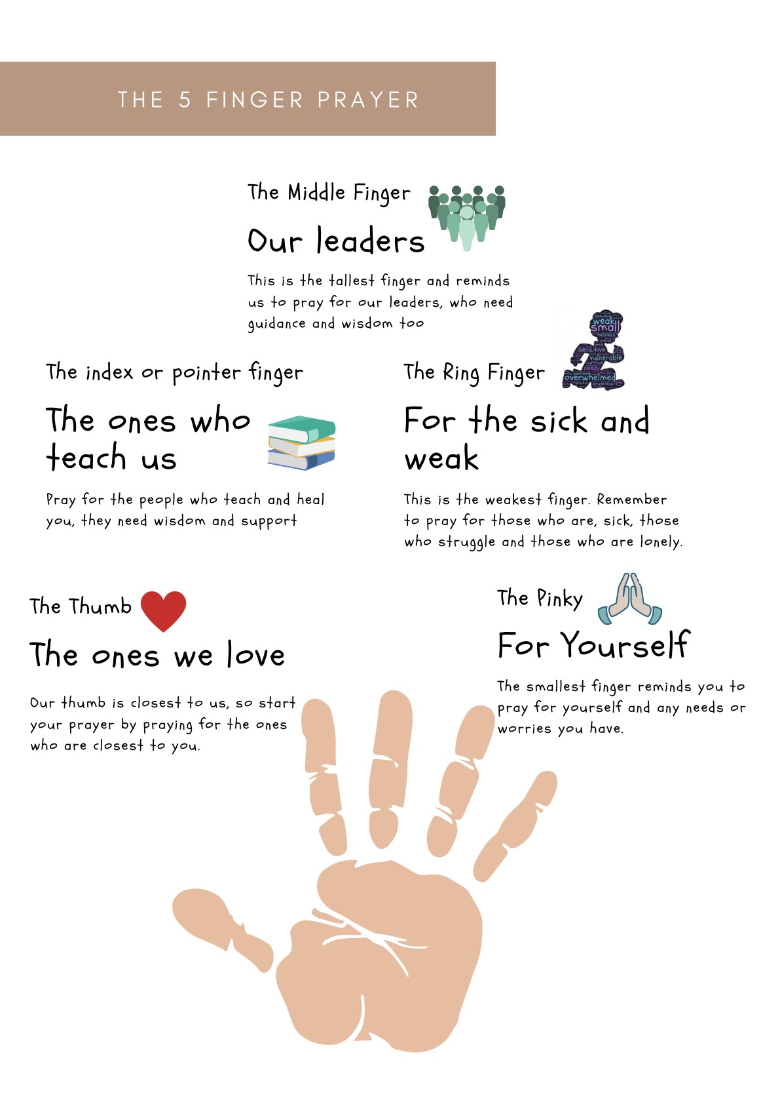

PRAYER BOOK ACTIVITY:

If you would prefer a more hands-on activity the children may like to make their own little prayer books. Below is a template to make a mini book from an A4 piece of paper.

Once you have folded the book the children can cut and paste some of their favourite prayer into it. They can decorate the front with MY PRAYER BOOK cover page, encourage them to also write any personal or family prayers they use regularly.

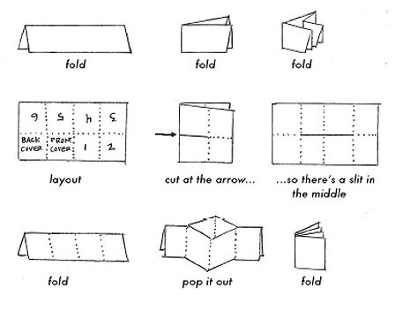

**The next few pages can be copied and used to paste into their prayer books.**

|  |  |
| --- | --- |
| **The Sign of the Cross**  In the name of the Father, Ki te ingoa o te Matua,  and of the Son,  o te Tamaiti,  Spirit  Tapu  and of the Holy  o te Wairua | **Grace or Food Blessing**  E te Atua  Whakapaingia ēnei kai  Kia ora ai mātou  Amene  God,  Bless this food,  So that it will strengthen us,  Amen |
| **Our Father**  Our Father in heaven.  Hallowed be your name,  your kingdom come,  your will be done,  on earth as in heaven.  Give us today our daily bread.  Forgive us our sins as we forgive those who sin against us.  Save us from the time of trial and deliver us from evil. Amen. | **Ko Te Patere**  E to mātou Matua i te rangi,  Kia whakatapua tou ingoa,  Kia tae mai tou rangatiratanga,  Kia whakaritea tou hiahia i te whenua  Kia pera ano i tō te rangi.  Homai ki a mātou äianei he taro ma  mātou mo tēnei ra.  Whakakahoretia o mātou hara, me mātou  e whakakore nei i ngā hara o te hunga  e hara ana ki a mātou.  Kaua mātou e tukua kia whakawaia,  Engari whakaorangia mātou i te kino. Amene. |
| **Hail Mary**  Hail Mary full of grace  The Lord is with you.  Blessed are you among women and  blessed is the fruit of your womb, Jesus.  Holy Mary, mother of God, pray for us sinners  now and at the hour of our death.  Amen. | **Ko Te Awe E Maria**   Awe, e Maria, e ki ana koe i te keratia  kei a koe te Ariki. E whakapaingia ana  koe i roto i nga wahine,  a e whakpaingia ana hoki a Hehu,  te hua o tou kopu.  E Hata Maria, e te matua wahine o te  Atua, inoi koe mo matou, mo te Hunga hara āianei, a, te haora o to ātou matenga rawa.  Amene |
| **Kororia**  Kororia ki te Matua, ki te Tamaiti,  Ki te Wairua Tapu,  he pera ano ināianei, a,  he pera tonu a ake ake.  Amene. | **Gloria**  Glory be to the Father and to the Son  and to the Holy Spirit,  as it was in the beginning,  is now and ever shall, be world without end.  Amen |

|  |  |
| --- | --- |
| **Thank You Prayer**  Thank you for the food we eat,  Thank you for the friends we meet.  Thank you for the birds that sing,  Thank you God for everything. | **Helping Prayer**  Hold my hand God,  lead the way,  Help me be good every day.  Let me know what’s wrong and right,  Keep me safe day and night,  Let me know what you have planned,  Lead the way God,  Hold my hand. |
| **Turning to you.**  Jesus help me to be  more like you  in everything I say  and everything I  do. | **Sorry prayer**  Merciful God I am sorry for choosing to turn away from you.  Through your loving grace,  give me the courage and strength  to make life giving choices  that turn me towards healthy relationships  with you, with those around me,  with myself and with the world. |
| **My Prayer**  I’m so thankful for ___________________  I’m sorry that I ______________________  I’m glad you helped me today with ______  I love you because ___________________  Please help me to ___________________  God of love hear my prayer. | **God**  Loving God, use my eyes to see new friends,  Listening God, use my ears to hear others, Helping God, use my hands to help,  Knowing God, use my mind to learn new things,  Strong God, remind my heart you are always there and I am never alone.  Amazing God may your light shine through me. |
| **Prayer starters:**  Hey God I’m sorry for …  Thank you God for …  God please take care of …  God please bless … | **Sad**  God, I feel sad,  I don’t even know why.  I’m not sure what to say to you,  but thank you for listening and loving me always.  Knowing you are there  makes me feel better.  Amen |

**Giving:** (Turning outwards to others) **(20 min)**

(Material needed: Large pieces of paper, pens, magazines, scissors and glue,)

When we use the gifts that God has given us to serve others, we can give of ourselves to others and are uniquely able to show our love for God. Lent reminds us to **turn** outwards and notice others.

How can you use your gifts to creatively give to those around you?

**Give** **encouragement** to those who are needing a boost, **give** time to someone who is lonely or stuck in a hospital, in their house or in a rest home.  **Give** your brothers and sisters **time by playing**a game with them or **helping** them with their homework.  **Give** someone your ear for a moment to really **listen** to what they are saying instead of thinking about the next thing you need to do.  
​**Give** your life to God each morning, **trusting** that God will provide. **Give** freely your **smiles**and during Lent this year **give** freely of your **love** too.

Set up: Sit in a circle and challenge the group to share one thing for which you have a talent or gift.

* Ask everyone to think of something they can do well, and that they feel good about. It does not have to be something at school, it could be physical like a back flip on the trampoline or something related to their personality like being happy, and always having a smile
* Go around the group saying ‘I am good at ...’

If a child wants to pass you can ask others to suggest what they are good at. If someone says they are not good at anything, you can acknowledge that they may *feel* that way but then you can suggest that you have noticed something about them like, they are good listeners, polite etc.

* Split the group into smaller groups and ask them to draw a life size outline of a body on the large piece of paper.
* Distribute pens, magazines, scissors, glue and a large sheet of paper big enough for a child to lie on.
* Invite the groups to decorate the bodies representing all the talents skills and abilities they have. They can write words, draw pictures or paste pictures on.
* To end this section, encourage each person to take one of the ‘Lent - Gift Certificates’ and fill it in, showing how they can **give** or use one of their gifts to help others.

e.g. The gift of reading stories to my little brother every night for a week

The gift of walking my nanna’s dog every weekend for lent

The gift of playing music for my family to enjoy

The gift of organising the kitchen cupboards

The gift of smiles to everyone I meet today

These gift certificates do not have to be given to people but can be used to remind the children of how they can give to others during lent. If they are to be kept you might like to place them on the fridge at home for a reminder.





**SHARE THE GOSPEL: (5 min)**

(Material needed: Bible)

Lent is a time for us to discover how we can **return** God to the centre of our lives. The bible has many stories that remind us to live like Jesus, here is one that tells us sometimes we confuse what we want with what God wants. Lent is a time to check in with God and make sure we are on the right track.

#### Mark 8:31-36

### **Jesus Predicts His Death**

**31**He then began to teach them that the Son of Man must suffer many things and be rejected by the elders, the chief priests and the teachers of the law, and that he must be killed and after three days rise again. **32**He spoke plainly about this, and Peter took him aside and began to argue with him.

**33**But when Jesus turned and looked at his disciples, he gave Peter an earful. “Get behind me, Satan!” he said. “You do not have in mind the concerns of God, but merely human concerns.”

**34**Then he spoke to the crowd and his disciples and said: “Whoever wants to be my disciple must deny themselves and take up their cross and follow me. **35**For whoever wants to save their life will lose it, but whoever loses their life for me and for the gospel will save it. **36**What good is it for someone to gain the whole world, yet lose their soul?

This is the Word of the Lord.

**OR**

**Galatians 5:13**

My friends, you were chosen to be free. So don't use your freedom as an excuse to do anything you want.  Use it as an opportunity to serve each other with love.

**SONG: (15 min)**

(Materials needed: computer with song and sound system)

Below are a few different options for song choices, depending on your ability and confidence. Some of them are more upbeat and lend themselves to actions while some are more reflective and quiet.

The lyrics can be found in the resources at the end of the workshop.

* *You may want to learn this song as a whole group*
* *Then break up into smaller groups to add actions to the verses.*
* *Return to the main group and sing through together with each group showing the actions they have created*

**Open My Eyes Lord.**

<https://www.youtube.com/watch?v=D-3FAR0cICI>

**Change my heart Oh God**

<https://www.youtube.com/watch?v=6MdRBp0XYkg&list=PLQFDK8kdIKc8DSmc3DnqxivM-8hKOVLBI&index=10>

**Every move I make**

<https://www.youtube.com/watch?v=hqbW0hfTkr8&list=PL-3aEhnkZ8LMPOZYNrVPV03-3fcjT_K3H&index=2>

**Will you come and follow me**

<https://www.youtube.com/watch?v=o469PRLdbHU>

**He is the Light**

<https://www.youtube.com/watch?v=fzoOmdZxrx8&list=PL-3aEhnkZ8LMPOZYNrVPV03-3fcjT_K3H&index=40>

**PRAYER SESSIONS (x2 Options):** OPTION 1 **(10-15min)**

(Materials needed: computer with song and sound system, prayer table, prayer cloth, candle and matches, quote from Mother Theresa on card or power point, scripture on card for someone to read)

Session 1: Silence

Prepare a prayer focus/table that is simple with a single candle on a purple cloth. You may like to have quiet music playing as people gather together in a circle of chairs

* Saint Teresa of Calcutta who some of you may know as Mother Theresa lived her life in service of others. Here is one of her famous quotes:
* “We need to find God, and he cannot be found in noise and restlessness. God is the friend of silence. See how nature - trees, flowers, grass - grows in silence; see the stars, the moon and the sun, how they move in silence ... we need silence to be able to touch souls.”
* This quote is the inspiration for our prayer session on silence.
* We begin with a verse from scripture.
* Reader: Psalm 62.1-2

“For God alone my soul waits in silence; from him comes my salvation. He alone is my rock and my salvation, my fortress; I shall never be shaken.”

(pause)

* Leader: Being silent can be hard. Trying to stop and quieten your mind is difficult. But the more you try and give yourself space, the easier it becomes.

**1.** Sit upright on a chair, uncross your arms and legs, lie your hands softly on your lap.

**2.** Keep your back straight.

**3.** Imagine someone has got something important to say to you. Sit, relaxed and comfortable, but attentive.

**4.** Let your eyes flutter closed and relax. Breathe deeply a few times, at your natural speed. Breathe in through your nose and out through your mouth. The deep breaths will help your whole body to relax.

**5.** Then breathe normally, but concentrate on your breathing. This will help relax your mind. Let all the other thoughts go by listening to your breathing.

**6.** It’s normal to get distracted by sounds and thoughts, but just take a breath and if it helps as you breathe through your nose say ‘Be still’ and as you breath out through your mouth, ‘and know that I am God’

**7.** Your breath is also the breath of God, the life-giving Spirit within you. ‘Be still’ – to know that you are alive. ‘Know that I am God’ to know that God’s Spirit is the breath within you.

**8.** You can enter into silence wherever you are, even with noise around you, because you can find that still point within yourself. When you are still you may have something to say to God, or you may like to sit in silence listening …

(After the appropriate time of silence 5-10min)

**9.** Our prayer is drawing to an end …begin to notice the sounds around you again, feel your feet on the ground your back on the chair … you may like to gently move your toes and fingers … take a final deep breath in and out and flutter your eyes open.

**Leader:** God we find you in the silences, help us to be more aware of you as we move through Lent. May we see you in those around us and hear your voice more clearly.

Amen

Finish this session by listening to a gentle piece of music or

**You are mine David Haas.**

<https://www.youtube.com/watch?v=Sgm9lkTNQmc>

*“In Quietness” by Luke Parker is also a great song to reflect on if you have it.*

* End with the sign of the cross: In the name of the Father and of the Son and of the Holy Spirit. Amen.

**PRAYER SESSIONS (x2 Options):** OPTION 2 **(10min)**

(Materials needed: copies of the finger labyrinth for everyone, attach them to a piece of card to make the path easier to follow, Mother Theresa’s prayer displayed for everyone to see or on individual copies)

Session 2: Labyrinth

* Sometimes it is difficult to relax our minds so the Labyrinth can help to relax the mind and allow you to become still and connected to God.
* The Labyrinth is an ancient prayer path that takes us on a silent journey and leads to God at the centre. It was used as an alternative to pilgrimages in the Middle Ages, and life sized ones, you can walk on can be found in the tiles of some churches. When we follow the twists and turns to the centre we may become aware of twists and turns in our own lives. Sometimes you are closer to the centre and sometimes further from the centre, but it is comforting to know that the path of the labyrinth always leads to the middle, the path you are on leads to God.
* Before we begin let’s take some time to quieten our minds.
* Notice your breathing, notice its rhythm.
* Perhaps you want to ask God to join you on this journey of prayer.
* As you begin there may be things you have to let go of to be present with God.
* Maybe you have a prayer, a thought or a challenge that you want to take with you.
* Trace your finger slowly along the path, take your time and pause where you need to.
* Notice at times that the path leads you closer to God then at times further away.
* When you reach the centre pause for a while, listen to God.
* When you are ready you can start to return down the same path.
* Let your prayer continue and when you reach the end sit quietly for a while with God in stillness.

To end this prayer session, pray this prayer from Mother Theresa together:

* Leader: The simple path:

Silence is prayer,

Prayer is faith,

Faith is love,

Love is service,

The fruit of service is peace.

Amen.

* End with the sign of the cross: In the name of the Father and of the Son and of the Holy Spirit. Amen.

Enlarge this image to use as a finger labyrinth:

**Conclusion: (10 min)**

(Materials needed: Computer with song and sound system)

To complete the work-shop finish off with a few games that again remind everyone about the value to silence:

* Silent Ball:

Everyone finds a place to stand around the room and then plants their feet so that they do not move. Introduce a ball and explain that the ball is passed around quickly with no noise. If anyone drops the ball they sit, if you throw a difficult pass you sit and it you make a noise you sit. The winner is the last one standing.

If they are really good you can introduce another ball or make the ball smaller and have a 2 second rule for holding onto the ball.

You may like to play Pictionary or Charades which also encourages silent communication!

**EXTRA MATERIAL:**

**TAKE HOME:**

Give each family a copy of the lent prayer and activity sheet to take home and pin to their fridge.

Encourage the families to use these during their Lenten journeys.

These activity sheets can be found on the website faithjourney.co.nz – Lent – Live your faith page, so some families may already have a copy of it.

**RESOURCES:**

**LORD I NEED YOU:**

*Verse 1*

Lord I come, I confess bowing here

I find my rest and without You, I fall apart

You're the one, that guides my heart

*Chorus 1*

Lord I need You, oh I need You ev'ry hour I need You

My one defense, my righteousness  
Oh God how I need You

*Verse 2*

Where sin runs deep, Your grace is more

Where grace is found is where You are

And where You are, Lord I am free

Holiness is Christ in me

Yes, where You are Lord I am free

Holiness is Christ in me

*Chorus 2*

Lord I need You, oh I need You ev'ry hour I need You

My one defense, my righteousness  
Oh God how I need You

*Bridge*

Teach my song to rise to You  
When temptation comes my way

And when I cannot stand I'll fall on You  
Jesus You're my hope and stay

And when I cannot stand I'll fall on You  
Jesus You're my hope and stay

*Tag*

Lord I need You, oh I need You ev'ry hour I need You

My one defense, my righteousness  
Oh God how I need You

My one defense, my righteousness  
Oh God how I need You

**YOU ARE MINE**

David Haas

**Lyrics**

I will come to you in the silence  
I will lift you from all your fear  
You will hear My voice  
I claim you as My choice  
Be still, and know I am near

I am hope for all who are hopeless  
I am eyes for all who long to see  
In the shadows of the night,  
I will be your light  
Come and rest in Me

Do not be afraid, I am with you  
I have called you each by name  
Come and follow Me  
I will bring you home  
I love you and you are mine

I am strength for all the despairing  
Healing for the ones who dwell in shame  
All the blind will see, the lame will all run free  
And all will know My name

Do not be afraid, I am with you  
I have called you each by name  
Come and follow Me  
I will bring you home  
I love you and you are mine

I am the Word that leads all to freedom  
I am the peace the world cannot give  
I will call your name, embracing all your pain  
Stand up, now, walk, and live

Do not be afraid, I am with you  
I have called you each by name  
Come and follow Me  
I will bring you home  
I love you and you are mine





­­